Software Requirements Specification
Building Materials Warehouse Management System (BMWMS) Report 3

Project Name | Building Materials Warehouse Management System
Vision & Scope Ref | Vision & Scope Document v[1.0]
RTW Ref | Building Materials Warehouse Management System_RTW.xlsx (Requirements Traceability Workbook)
SRS Version | v1.0.0
Date Created | 05/06/2026
Last Updated | 12/06/2026]
Author(s) | [Name / Role]
Reviewer(s) | [Name / Role]
Status | In Review

How to Use This Template
Template conventions
This template defines the structure and writing rules for an SRS that uses three
complementary specification methods:
• Scenario / Narrative — Part 2: real-world business flows
• Feature Description — Part 3: precise system behaviour
• Non-Functional Requirements — Part 6: quality constraints
• Data Requirements — Part 4: entities, constraints, state transitions

Colour coding in this template:
BLUE box = Guidance — explains what to write in this section
GREEN box = Sample placeholder — shows format of example content
PURPLE box = Diagram placeholder — where to insert a diagram
GRAY box = Excel reference — content maintained in RTW.xlsx
RED box = Negative AC (Acceptance Criteria) guidance
AMBER box = Boundary Value guidance

Fields shown as [Italic gray text] are fill-in placeholders — replace with real content.
Delete all blue Guidance boxes before distributing the completed SRS.

Companion files to create alongside this SRS:
• Vision & Scope Document (use the V&S Template)
• [ProjectName]_RTW.xlsx (use the RTW Template)

Document Change History
Version | Date | Changes | Author
v1.0.0 | 12/06/2026 | Initial SRS baseline | [Author]

Part 0 — Document Overview
This Software Requirements Specification (SRS) defines the functional, data, and non-functional requirements of the BMWMS (Business Management Warehouse System). The document complements the Vision & Scope Document by translating business needs into detailed system specifications that can be used by Business Analysts, Developers, Testers, and Project Stakeholders throughout the software development lifecycle.

The SRS focuses on system behaviours, feature descriptions, data requirements, business rules, and quality attributes. Detailed requirement traceability, use case inventory, permission matrix, data dictionary, and non-functional requirement tracking are maintained separately in the RTW workbook.

Document | Content
Vision & Scope Document | Product background, business problem, gap analysis, proposed solution, business scope, limitations, assumptions
RTW.xlsx Sheet 2 | Full Use Case List
RTW.xlsx Sheet 3 | Feature Traceability Matrix
RTW.xlsx Sheet 4 | Permission Matrix
RTW.xlsx Sheet 5 | Data Dictionary
RTW.xlsx Sheet 6 | Business Rules Register
RTW.xlsx Sheet 7 | NFR Tracker
RTW.xlsx Sheet 8 | Open Issues Log
RTW.xlsx Sheet 9 | Change Log

Part 1 — System Overview

1.1 System Objective & Business Context
Reference: Vision & Scope Document v1.0 – Sections 1, 2, and 3.

The objective of BMWMS is to provide a centralized warehouse management solution that enables organizations to efficiently manage warehouses, storage locations, inventory movements, stock levels, purchase receipts, stock issuance, and warehouse reporting while improving inventory accuracy and operational efficiency.

1.2 Technical Scope
Dimension | In Technical Scope | Notes
Modules | Warehouse Management  Product Management  Supplier Management  Inbound Management  Outbound Management  Inventory Audit  Warehouse Transfer  Reporting & Analytics | Core modules of BMWMS
Integrations | None in Version 1.0 | The system operates independently without external system integration
Tech Stack | Front-end: Razor Pages, Back-end: ASP.NET Web API, Database: Microsoft SQL Server | Web-based application
Data Boundary | Warehouses, Storage Locations, Products, Product Groups, Product Attributes, Suppliers, Inbound Receipts, Outbound Orders, Inventory Transactions, Stock Audit Records, Transfer Requests, Reports | Managed and owned by BMWMS
Excluded (Tech) | ERP Integration, Mobile Application, Barcode Scanner Devices, IoT Warehouse Sensors, AI Forecasting | Planned for future releases

Diagram Placeholder — System Context Diagram
INSERT HERE: Context Diagram showing the system and all external entities.
Show data flows in (solid arrows) and out (dashed arrows) for each entity.
Recommended tool: draw.io | Export PNG and embed at full content width.
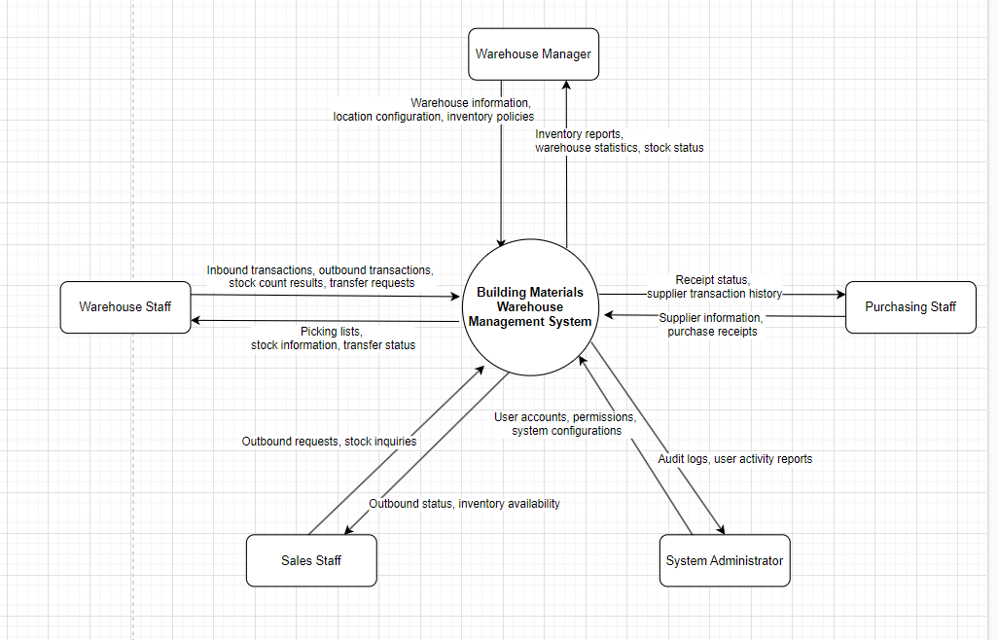
The BMWMS system serves as the central platform for managing warehouse operations. Internal users, including Warehouse Managers, Warehouse Staff, Purchasing Staff, Sales Staff, and System Administrators, interact directly with the system to manage inventory, warehouse activities, and operational reports. Version 1.0 does not include integrations with external enterprise systems or third-party services.

Role | Access Level | Primary Feature Areas
Warehouse Manager | Internal | Warehouse Management, Storage Location Management, Inventory Monitoring, Stock Audit, Warehouse Transfer, Reporting & Analytics
Warehouse Staff | Internal | Inbound Management, Outbound Management, Inventory Audit Execution, Warehouse Transfer Execution
Purchasing Staff | Internal | Supplier Management, Product-Supplier Mapping, Purchase Receiving, Inbound Management
Sales Staff | Internal | Outbound Request Management, Inventory Inquiry, Outbound Tracking
System Administrator | Internal | User Management, Role & Permission Management, System Configuration, Audit Monitoring

Permission Matrix → Report 3.1_RTW Sheet 4
Detailed Role x Feature x Action permission matrix (F/E/R/O/— per action).
Update Report 3.1_RTW Sheet 4 when roles or feature access rules change.

Use Case List → Report 3.1_RTW Sheet 2
Full Use Case List with: UC ID, Name, Primary Actor, Secondary Actor(s),
Pre/Postcondition, Related FT-xx, Related SC-xx, Priority, Status.
To add/update/deprecate a UC: edit RTW.xlsx Sheet 2 directly.
Then update the Use Case Diagram below.

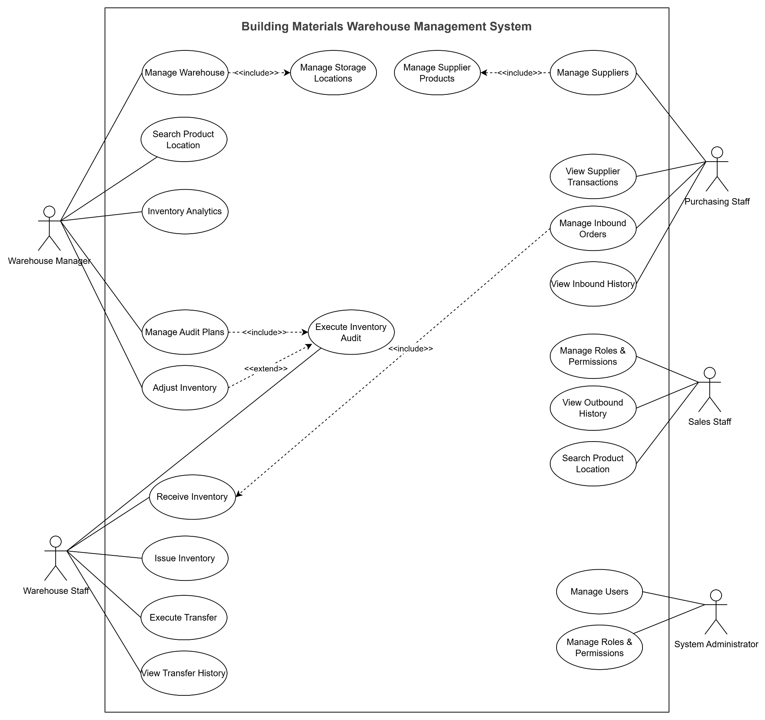

Diagram Placeholder — Use Case Diagram (System Overview)
INSERT HERE: One high-level Use Case Diagram — all actors + grouped use cases.
This is a SUMMARY diagram. Do NOT draw one diagram per individual use case.
Actors: internal roles on left, external systems on right.
Group use cases by module inside the system boundary rectangle.
Use UML notation: stick figures, ovals, lines, <<include>> / <<extend>> where applicable.
For individual UC detail: Report 3.1_RTW Sheet 2 + Scenarios in Part 2.
Tool: draw.io | Export PNG and embed at full content width.

1.4 Glossary
Guidance — 1.4
Define SRS-specific technical and domain terms that appear in Scenarios,
Feature Descriptions, and Acceptance Criteria.
Do NOT repeat general business terms already defined in V&S.
Always include: AC-xx, NAC-xx, BV-xx conventions.

Term | Definition | Used in
[Key domain term] | [Plain-language definition] | [FT-xx, SC-xx]
AC-xx | Acceptance Criterion — a positive, testable condition for feature completion | All FT-xx
NAC-xx | Negative Acceptance Criterion — failure/rejection/boundary-breach test condition | All FT-xx
BV-xx | Boundary Value note — defines valid/invalid ranges for a specific constraint | All FT-xx
BR-xx | Business Rule ID — full definition in RTW.xlsx Sheet 6 | All FT-xx

1.5 Feature Traceability Bridge (V&S → SRS)
Guidance — 1.5
Full traceability (FE-xx → FT-xx → UC → Scenario → Data → NFR → BR → Test → Sprint)
is maintained in RTW.xlsx Sheet 3.
This section contains only a quick-reference summary table (FE → FT mapping).
Every V&S Feature (FE-xx) must have a corresponding SRS Feature (FT-xx).
Any FE-xx without an FT-xx is unspecified — flag as Pending.

Full traceability matrix → [ProjectName]_RTW.xlsx Sheet 3
Maintained in: RTW.xlsx Sheet 3: Feature Traceability Matrix

V&S Feature (FE-xx) | Feature Name in V&S | Maps to SRS (FT-xx) | Status
FE-01 | [Feature name] | FT-01 | Specified / Pending
FE-02 | [Feature name] | [FT-xx] | Pending
[Add rows]

Part 2 — Scenario / Narrative
Guidance — Part 2
Scenarios describe real-world business flows in natural language.
Reviewed and approved by stakeholders BEFORE Feature Descriptions are written.

Rules for writing good scenarios:
• Use a specific persona name (not just a role label) — makes flows tangible
• Include context: device, time of day, prior state
• Keep to 1–3 paragraphs per scenario
• Always include 1–2 most important exception / alternate flows
• Do NOT describe UI elements or implementation details
• Do NOT list features — describe what a real person does and experiences

Diagram: add Activity or Sequence Diagram after narratives with complex branching
or cross-system interactions (see placeholder below each scenario).

Close Part 2 with a Scenario List table summarising all scenarios.

SC-01 — Configure Warehouse Structure
Field | Value
Business Flow | Configure warehouse structure and storage locations
Primary Actor | Warehouse Manager
Pre-condition | User has warehouse management permission
Post-condition | Warehouse structure and storage locations are configured
Related Feature | F01.01, F01.02

Narrative:

Warehouse Manager accesses the warehouse management module to create and maintain warehouse information. The manager defines warehouse details such as warehouse code, warehouse name, address, and operational status.

The manager then configures storage locations inside the warehouse, including zones, racks, shelves, and bins. The system validates location hierarchy and capacity information before saving.

Once configuration is completed, the warehouse structure becomes available for inbound, outbound, transfer, and inventory audit operations.

Key Exception / Alternate Flows:
Guidance — exception flows
List 1–2 most important failure or alternate paths.
Format: [Trigger]: [What the system does] — [Outcome for the user].
Do not attempt to cover every edge case here — that belongs in NAC-xx in Part 3.

Diagram Placeholder — [SC-xx Diagram Type]
INSERT HERE: [Activity Diagram / Sequence Diagram] for this scenario.
Activity Diagram: for flows with multiple decision branches.
Sequence Diagram: for flows with significant cross-system interactions.
Tool: draw.io | File: [ProjectName]_[SC-xx]_[DiagramType].drawio
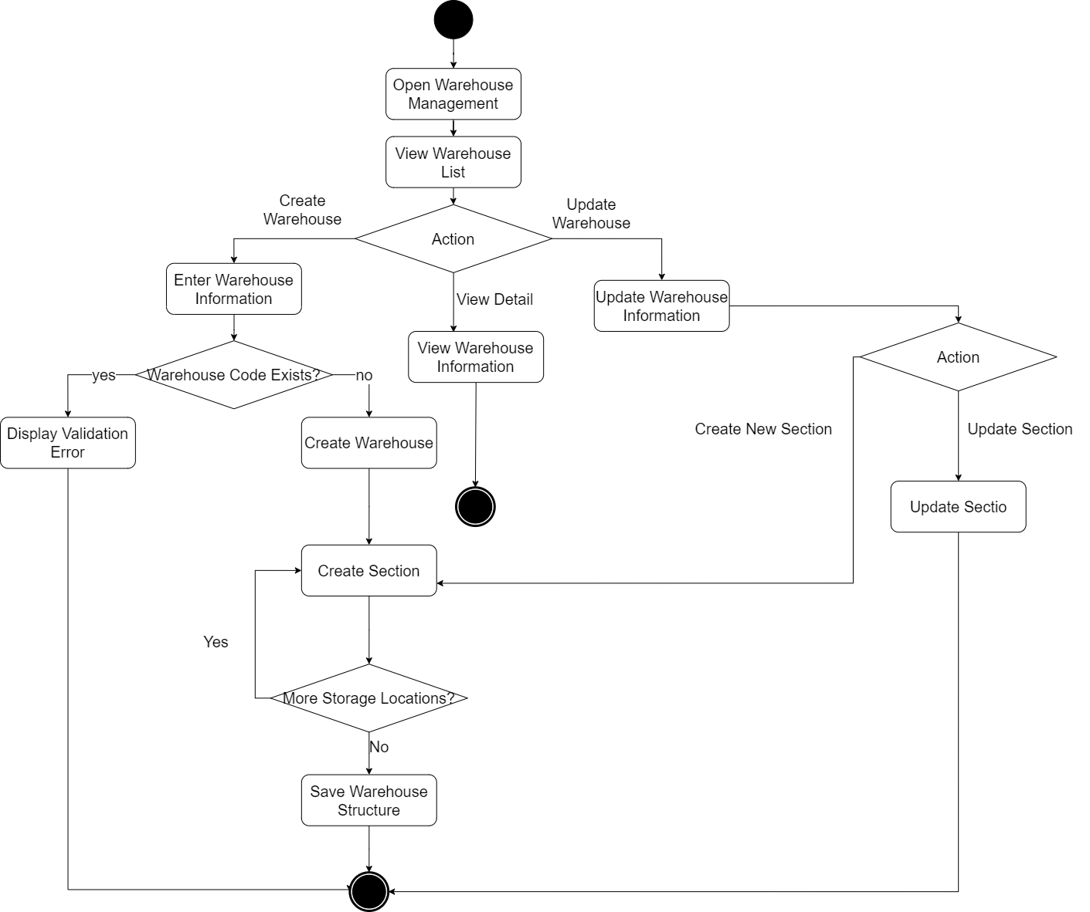

SC-02 — Manage Product Master Data

Field | Value
Business Flow | Manage product master information
Primary Actor | Warehouse Manager
Pre-condition | Product categories and attributes are available
Post-condition | Product information is available for inventory transactions
Related Feature | F02.01, F02.02, F02.03
Related UC | UC11–UC20
Narrative:
Warehouse Manager creates and maintains product master data. Product information includes product code, product name, unit of measure, barcode, product group, and product attributes.

The manager organizes products into groups and configures product attributes that will be used during inventory operations and reporting.

After configuration is completed, products become available for purchasing, receiving, issuing, transfer, and inventory audit processes.

SC-03 — Locate Product in Warehouse

Field | Value
Business Flow | Search product location
Primary Actor | Warehouse Staff
Pre-condition | Product inventory exists in warehouse
Post-condition | Product location is identified
Related Feature | F01.03
Related UC | UC10
Narrative:
Warehouse Staff searches for a product using product code, barcode, or product name.

The system retrieves current inventory records and displays the exact warehouse, zone, rack, and bin where the product is stored.

The staff uses the location information to support picking, receiving, counting, or transfer activities.

SC-04 — Manage Suppliers

Field | Value
Business Flow | Maintain supplier information
Primary Actor | Purchasing Staff
Pre-condition | User has supplier management permission
Post-condition | Supplier information is updated
Related Feature | F03.01, F03.02, F03.03
Related UC | UC22–UC28
Narrative:
Purchasing Staff manages supplier information and supplier-product relationships.
The staff creates new suppliers, updates supplier information, reviews supplied products, and tracks historical purchasing transactions.
The maintained supplier information is later used during purchase and receiving processes.

SC-05 — Receive Inventory

Field | Value
Business Flow | Receive goods into warehouse
Primary Actor | Warehouse Staff
Pre-condition | Approved inbound order exists
Post-condition | Inventory quantity increases
Related Feature | F04.01, F04.02, F04.03
Related UC | UC29–UC36
Narrative:
Purchasing Staff creates an inbound order based on supplier deliveries.

Warehouse Staff receives physical goods and verifies quantity, product information, and supplier documents. The system records received quantities and updates inventory levels.

The staff assigns storage locations to received products. Inventory records and inbound transaction history are updated successfully.
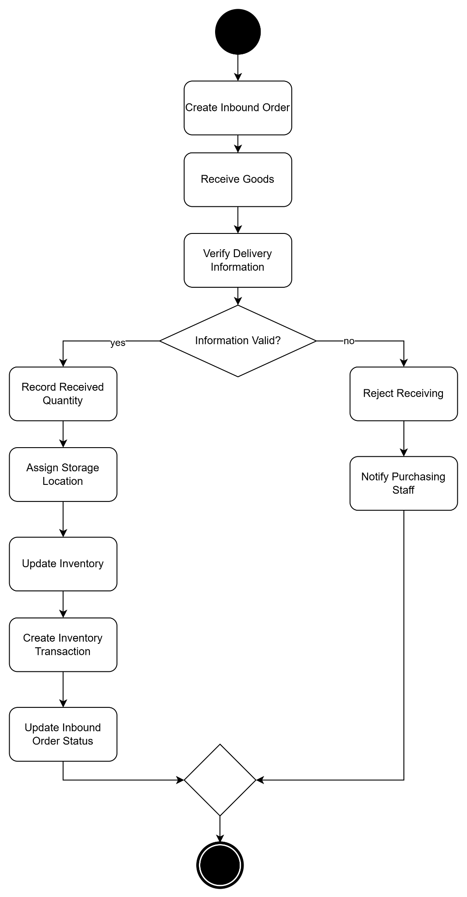

SC-06 — Issue Inventory

Field | Value
Business Flow | Process outbound inventory
Primary Actor | Warehouse Staff
Secondary Actor | Sales Staff
Pre-condition | Approved outbound request exists
Post-condition | Inventory quantity decreases
Related Feature | F05.01, F05.02, F05.03
Narrative:
Sales Staff creates an outbound request for products.

Warehouse Staff reviews the request and verifies inventory availability. The system validates stock quantity before allowing outbound processing.

After confirmation, inventory quantities are deducted and outbound transaction history is recorded.
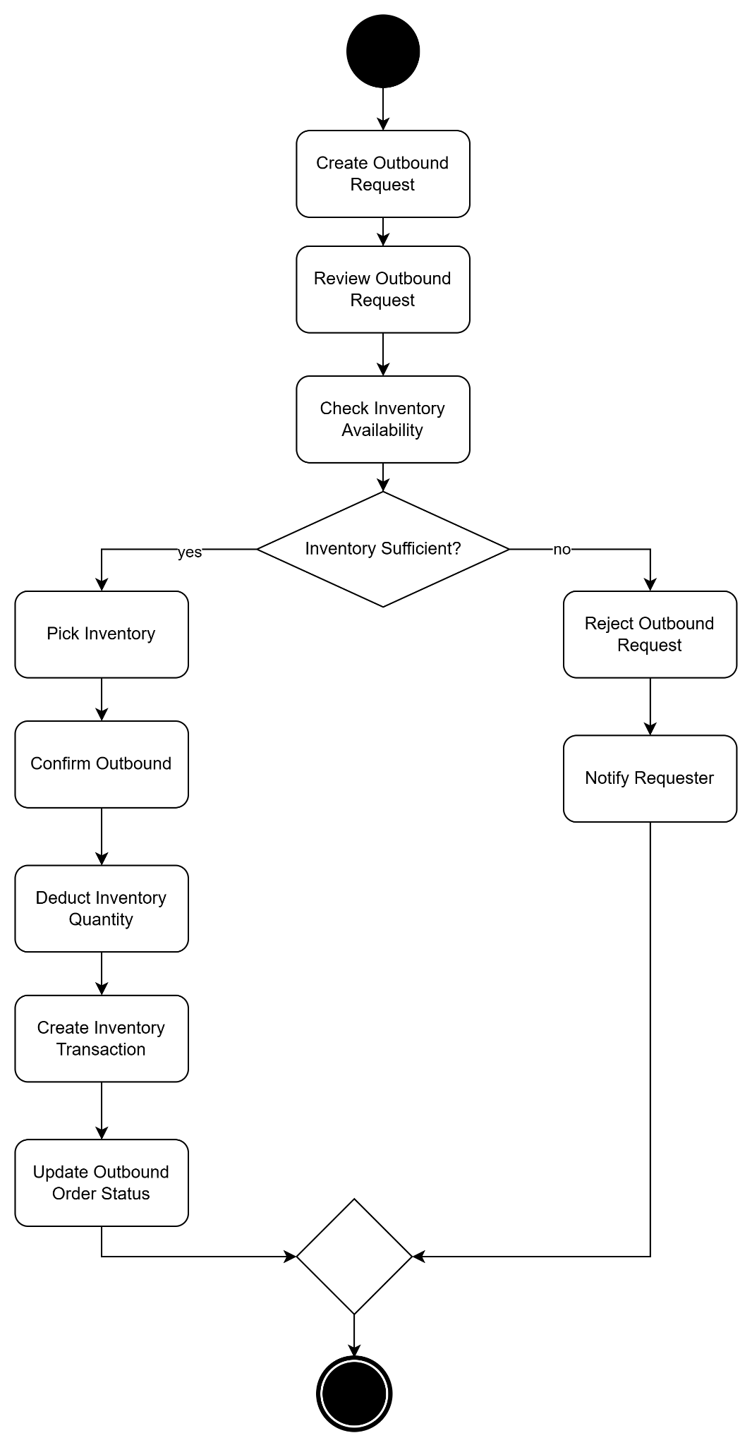

SC-07 — Perform Inventory Audit

Field | Value
Business Flow | Conduct inventory audit
Primary Actor | Warehouse Manager
Secondary Actor | Warehouse Staff
Pre-condition | Audit plan exists
Post-condition | Audit results are recorded
Related Feature | F06.01, F06.02
Narrative:
Warehouse Manager creates an inventory audit plan and assigns warehouses or product groups for counting.

Warehouse Staff performs physical counting and records actual inventory quantities.

The system compares actual quantities with recorded inventory and identifies discrepancies for review.

SC-08— Adjust Inventory

Field | Value
Business Flow | Adjust inventory discrepancies
Primary Actor | Warehouse Manager
Pre-condition | Inventory discrepancies exist
Post-condition | Inventory balances are corrected
Related Feature | F06.03
Related UC | UC50, UC51
Narrative:
After audit completion, Warehouse Manager reviews discrepancy reports generated by the system.

The manager approves adjustment transactions to reconcile inventory records with actual physical stock.

The system updates inventory balances and maintains adjustment history for future auditing purposes.

SC-09— Transfer Inventory Between Warehouses

Field | Value
Business Flow | Transfer products between warehouses
Primary Actor | Warehouse Staff
Pre-condition | Transfer request is approved
Post-condition | Inventory is moved successfully
Related Feature | F07.01, F07.02, F07.03
Related UC | UC52–UC59
Narrative:
Warehouse Staff creates a transfer request specifying source warehouse, destination warehouse, and transfer quantities.
The source warehouse confirms outbound transfer while the destination warehouse confirms receipt.
The system updates inventory balances in both warehouses and records transfer history.

SC-10 — Monitor Inventory Performance

Field | Value
Business Flow | Analyze inventory and warehouse performance
Primary Actor | Warehouse Manager
Pre-condition | Inventory transaction data exists
Post-condition | Performance statistics are available
Related Feature | F08.03, F08.04, F08.05
Related UC | UC64–UC70
Narrative:
Warehouse Manager accesses analytical dashboards to review warehouse performance.
The system aggregates inventory movement, warehouse utilization, supplier performance, and operational activities.
The manager uses the information to identify trends and support inventory planning decisions.

Scenario List
ID | Scenario Name | Primary Actor | Maps to Feature(s) | Priority
SC-01 | Configure Warehouse Structure | Warehouse Manager | F01.01 Warehouse Management, F01.02 Storage Location Management | High
SC-02 | Manage Product Master Data | Warehouse Manager | F02.01 Product Management, F02.02 Product Group Management, F02.03 Product Attribute Management | High
SC-03 | Locate Product in Warehouse | Warehouse Staff | F01.03 Product Location Tracking | Medium
SC-04 | Manage Suppliers | Purchasing Staff | F03.01 Supplier Management, F03.02 Supplier Product Management, F03.03 Supplier Transaction Tracking | High
SC-05 | Receive Inventory | Warehouse Staff | F04.01 Inbound Order Management, F04.02 Inventory Receiving, F04.03 Inbound History Tracking | Critical
SC-06 | Issue Inventory | Warehouse Staff | F05.01 Outbound Order Management, F05.02 Inventory Issuing, F05.03 Outbound History Tracking | Critical
SC-07 | Perform Inventory Audit | Warehouse Manager | F06.01 Inventory Audit Planning, F06.02 Inventory Audit Execution | High
SC-08 | Adjust Inventory Discrepancies | Warehouse Manager | F06.03 Inventory Discrepancy Adjustment | High
SC-09 | Transfer Inventory Between Warehouses | Warehouse Staff | F07.01 Transfer Request Management, F07.02 Warehouse Transfer Execution, F07.03 Transfer History Tracking | High
SC-10 | Monitor Inventory Performance | Warehouse Manager | F08.03 Product Analytics, F08.04 Warehouse Analytics, F08.05 Supplier Analytics | Medium

Part 3 — Feature Description
Guidance — Part 3 convention
Feature Descriptions specify WHAT the system does — written after scenarios are approved.
Each FT-xx maps to at least one V&S feature (FE-xx) via the traceability bridge (Part 1.5).

Every FT-xx contains five sub-sections:
1. Header table (source feature, scenario, UC, summary)
2. System Behaviour (what the system does — use active system language + specific numbers)
3. Applicable Business Rules (BR IDs only — full definitions in RTW.xlsx Sheet 6)
4. Positive Acceptance Criteria (AC-xx) — happy path, verifiable conditions
5. Negative Acceptance Criteria (NAC-xx) — failure, rejection, invalid inputs
6. Boundary Value Notes (BV-xx) — valid/invalid ranges with test points

Business Rule convention (Approach B — master in RTW.xlsx):
List BR IDs only in each FT-xx. Full rule text is in RTW.xlsx Sheet 6.
This eliminates duplication and ensures a single point of update.

Writing rules:
• 'The system automatically...' / 'The system displays...' / 'The system rejects...'
• Specific numbers always: '15 minutes', 'within 90 seconds', 'maximum 10 units'
• Never vague: 'quickly', 'soon', 'appropriate', 'standard'
• Do NOT describe UI layout or technical implementation

FT-01 — [Feature Name]
Source Feature (V&S) | [FE-xx]
Related Scenario | [SC-xx]
Related UC | [UC-xx (RTW.xlsx Sheet 2)]
Summary | [One sentence: what the system does for whom, and what value it delivers.]

System Behaviour:
Guidance — System Behaviour
Describe the system's behaviour in operational terms. Structure as:
Trigger → Processing → Output
Include: polling/push mechanism, timing (every X seconds), data normalisation,
display rules, sorting, and any automatic actions.
Use specific numbers. Reference BR IDs for any constraint that has a policy basis.

[Describe system behaviour here. 2–4 paragraphs. Active voice. Specific numbers.]

Applicable Business Rules:
BR-xx, BR-yy → See [ProjectName]_RTW.xlsx Sheet 6 for full definitions.

Positive Acceptance Criteria (AC):
Guidance — Positive AC
Write 2–5 conditions that must be TRUE for this feature to be considered done.
Each AC must be independently testable — a QA engineer should be able to write
a test case from each AC without asking questions.
Format: 'AC-xx: When [condition], the system [does X] within [Y time / Z count].'

- AC-01: [When X happens, the system does Y. Specific and measurable.]
- AC-02: [Another verifiable positive condition.]

Negative Acceptance Criteria (NAC) — FT-01
Write 3–5 failure / rejection scenarios that the system must handle correctly.
For each NAC, specify:
• The invalid input, forbidden action, or failure condition
• The exact system response (HTTP status code, error message text, or behaviour)
• Any side effects that must NOT occur (no record created, no stock changed, etc.)
• Any audit/logging requirement

Common NAC categories to cover:
• Invalid input: malformed payload, missing required field, wrong data type
• Boundary breach: value outside valid range (reference BV-xx)
• Unauthorised access: role without permission attempts an action → 403
• Race condition: two users attempting the same action simultaneously
• Stale / duplicate: event received for already-closed or already-processed state
• Timer expiry: action attempted after a time window has closed

Replace this guidance box with actual NAC-xx entries when writing the real SRS.

Boundary Value Notes (BV) — FT-01
For each numeric constraint in this feature, define:
• Lower boundary (minimum valid value)
• Upper boundary (maximum valid value)
• Default value
• Invalid values just outside boundaries
• Explicit test points for QA (parameterised test inputs)

Format:
BV-xx [Constraint name]:
Valid: [min] to [max] | Default: [value]
Invalid: [below min], [above max]
Test points: [value1 (label)], [value2 (label)], [boundary], [boundary+1 (breach)]

Replace this guidance box with actual BV-xx entries when writing the real SRS.

Diagram Placeholder — [FT-01 Diagram if needed]
INSERT HERE only if this feature requires a visual to clarify integration or flow.
Not every feature needs its own diagram — use sparingly.
Candidates: integration flow (for API-heavy features), state machine (if complex state).

FT-02 to FT-0N — [Additional Features]
(Repeat the FT structure above for each feature. Add as many FT-xx sections as needed, one per feature.)

ID | Feature Name | Source (V&S) | Scenario | Status
FT-01 | [Name] | FE-xx | SC-xx | Specified / Draft
FT-02 | [Name] | FE-xx | SC-xx
FT-0N | [Add rows]

Part 4 — Data Requirements
Guidance — Part 4
Four sub-sections:
4.1 Core Entities & Relationships — entity summary (not full ERD)
4.2 Data Constraints & Integrity Rules — system-enforced rules (distinct from BRs)
4.3 Data Retention & Ownership — how long, who owns, who can delete
4.4 State Transition Table — for any entity with a multi-step lifecycle

What belongs in RTW.xlsx Sheet 5 (not here):
Full attribute-level detail: data type, nullable, unique, default, validation rule

What belongs in the TDS (not here):
Physical schema, indexes, migration scripts, ORM mappings

4.1 Core Entities & Relationships
Guidance — 4.1
List each entity, its purpose in one sentence, and its key relationships.
Use the notation: Entity A --< Entity B (one-to-many), A -- B (one-to-one).
Full attribute definitions are in RTW.xlsx Sheet 5.
Place the ERD diagram placeholder below — insert a conceptual ERD (not physical schema).

Diagram Placeholder — Entity Relationship Diagram (ERD)
INSERT HERE: Conceptual ERD showing core entities and their relationships.
Use crow's foot notation. Show cardinality and key foreign keys.
This is a conceptual ERD for requirement purposes — physical ERD belongs in TDS.
Tool: draw.io | File: [ProjectName]_ERD.drawio

Entity | Purpose (one sentence) | Key Relationships | Full Attributes
[Entity 1] | [What it represents] | [Relationships to other entities] | RTW.xlsx Sheet 5
[Entity 2] |  |  | RTW.xlsx Sheet 5
[Add rows] |  |  | RTW.xlsx Sheet 5

4.2 Data Constraints & Integrity Rules
Guidance — 4.2
List constraints that affect system behaviour at the requirement level.
These are data integrity rules, NOT business policy rules (those are in RTW.xlsx Sheet 6).
Integrity rules include: immutability, uniqueness, referential integrity, atomic operations,
valid value ranges enforced at the data layer.
Each DC-xx should reference the feature (FT-xx) or state transition (Part 4.4) it supports.

ID | Constraint | Entities Affected | Violation Behaviour
DC-01 | [Constraint description] | [Entity name(s)] | [What system does when violated]
DC-02 | [Add rows as needed]

4.3 Data Retention & Ownership Policy
Guidance — 4.3
For each data type, specify: how long it must be kept, who owns it, who can delete it,
and the regulatory or policy basis for these decisions.
This drives: automated purge jobs, data deletion request handling (GDPR/local law),
and audit log immutability requirements.

Data Type | Retention Period | Owner | Deletion Authority | Basis
[Data type] | [Duration / condition] | [Role / entity] | [Who / when] | [Law / policy]
[Add rows]

4.4 [Entity] State Transition Table
Guidance — 4.4 State Transition Table
Create one State Transition Table for each entity with a significant lifecycle
(e.g. Order, Ticket, Request, Task).

The table has two parts:
(a) Valid Transitions — every legal state change with trigger, guard, and system action
(b) Invalid Transitions — explicit list of forbidden transitions that must be rejected

Each row in (a) should correspond to 1–2 positive test cases.
Each row in (b) should correspond to 1 negative test case (NAC).

Columns for Valid Transitions:
From State | Trigger Event | Guard Condition | To State | System Action

Columns for Invalid Transitions:
From State | Attempted Transition | Why Invalid | System Response

Close this section with a QA guidance note listing the key edge cases to test.
Add a Sequence/State Machine diagram placeholder.

Valid State Transitions:

From State | Trigger Event | Guard Condition | To State | System Action
[Initial state] | [Event that fires the transition] | [Condition that must be true] | [New state] | [What system does automatically]
[State] | [Trigger] | [Guard] | [State] | [Action]
[Add rows]

Invalid Transitions (must be rejected — DC-01):

From State | Attempted Transition | Why Invalid | System Response
[State] | [Forbidden action] | [Reason: backward / terminal / skip] | HTTP 4xx + error message
[Add rows]

Diagram Placeholder — [Entity] State Machine Diagram
INSERT HERE: State Machine / State Diagram for this entity's lifecycle.
Label each transition arrow with the trigger event.
Show terminal states (no outgoing transitions) clearly.
Tool: draw.io | File: [ProjectName]_[Entity]StateMachine.drawio

Part 5 — Business Rules
Guidance — Part 5
All Business Rules are maintained exclusively in RTW.xlsx Sheet 6 (master).
This Part contains only an Excel reference box and a quick-reference ID list.
Each FT-xx in Part 3 lists only the applicable BR IDs — never the full text.
This eliminates duplication and ensures a single update point.

Business Rules Register → [ProjectName]_RTW.xlsx Sheet 6
All Business Rules are maintained in: [ProjectName]_RTW.xlsx → Sheet 6
Each FT-xx in Part 3 lists applicable BR IDs only.
Full rule text, trigger conditions, exception handling, source: RTW.xlsx Sheet 6.

Current BRs: [List BR-01 through BR-xx with one-line description each]

Part 6 — Non-Functional Requirements (NFR)
Guidance — Part 6
NFR definitions belong here. Test method, tool, measured result, and status
are tracked in RTW.xlsx Sheet 7: NFR Tracker.

Rules for writing good NFRs:
• Measurable: '< 2 seconds' not 'must be fast'
• Conditional: state the load / context explicitly
• Achievable: based on real tech stack and budget
• Categorised: group by dimension (Performance, Security, etc.)

Standard NFR categories (add/remove as needed for your project):
6.1 Performance 6.2 Scalability 6.3 Availability & Reliability
6.4 Security 6.5 Usability 6.6 Maintainability 6.7 Compliance

6.1 Performance
ID | Requirement | Condition | Priority
NFR-P01 | [Page / operation] loads in < [X] seconds | [Load condition: N users, network type] | High / Medium / Low
NFR-P0N | [Add rows]

6.2 Scalability
ID | Requirement | Notes
NFR-S01 | System supports >= [N] concurrent users without degradation | Verified by load test
NFR-S0N | [Add rows]

6.3 Availability & Reliability
ID | Requirement | Notes
NFR-A01 | Uptime >= [X]% per month | Excludes announced maintenance
NFR-A0N | [Add rows]

6.4 Security
ID | Requirement | Notes
NFR-SEC01 | All traffic over HTTPS / TLS 1.2+ | HTTP redirects to HTTPS
NFR-SEC0N | [Add rows]

6.5 Usability
ID | Requirement | Notes
NFR-U01 | [Usability requirement] | [Test method or device scope]
NFR-U0N | [Add rows]

6.6 Maintainability
ID | Requirement | Notes
NFR-M01 | [Maintainability requirement]
NFR-M0N | [Add rows]

6.7 Compliance
Guidance — Compliance NFRs
List legal and regulatory requirements relevant to your project context.
Common examples: data retention law, personal data protection, financial reporting.
Always state the specific regulation or policy — not just 'comply with the law'.

ID | Requirement | Regulatory Basis
NFR-C01 | [Compliance requirement] | [Specific law / regulation / policy]
NFR-C0N | [Add rows]

Appendices

Appendix A — RTW.xlsx Reference
All tracking artefacts → [ProjectName]_RTW.xlsx
Sheet 1: Overview Dashboard Sheet 2: Use Case List
Sheet 3: Feature Traceability Sheet 4: Permission Matrix
Sheet 5: Data Dictionary Sheet 6: Business Rules Register
Sheet 7: NFR Tracker Sheet 8: Open Issues Log
Sheet 9: Change Log

Appendix B — Diagram Index
Guidance — Diagram Index
List every diagram referenced in this SRS.
For each: diagram type, where it is referenced, and the source draw.io filename.
When the diagram is created, export as PNG and embed at the placeholder location.

Diagram | Type | Referenced in | File Name
[Diagram name] | [Type: Context / UC / ERD / State Machine / Activity / Sequence] | [Part X.Y] | [ProjectName]_[Name].drawio
[Add rows]

— End of Template —

